Multinomial Naïve Bayes and Bernoulli Models for Classification
Kent Roller

Introduction
Text data often provides valuable insight into how customers feel about a product or service, and has been a boon to businesses who take advantage of the data. Gains in compute power and sharp decreases in the cost of storage solutions coupled with the exponential increase in their capacity has yielded this possibility. All of this with a much lower upfront investment than what would have been required just a decade or two ago. Text data can be taken and sentiment analysis can be performed on the text to gauge how people “fee” about a certain thing. Data in text form is not relegated to being sufficient for sentiment analysis alone, as it can also be used for tasks such as lie detection. In order to make the most of the capabilities, the interested party must first perform the necessary steps to make the data ready for use with a machine learning algorithm. The type of machine learning algorithm is dependent on the task at hand, and as such there should not be a one size fits all approach considered. Here, we will look at using the multinomial naïve bayes method to train a model for classification purposes. After training the model, the model will be used to try and ‘predict’ the appropriate label for the text supplied. Two different label types will be compared, ‘sentiment’ , and ‘lie’, to gauge the effectiveness of the selected algorithm at each task. After using the multinomial naïve bayes method, we will then prepare the data for use with the Bernoulli model for comparison. To conclude we will then alter some of the pre processing steps and/or hyperparameters of the model for additional analysis.

Method
The data set consists of reviews of restaurants in the Syracuse, NY area. Each observation has been manually labeled prior to acquisition, with two labels per observation. The two labels are “lie” with options of ‘f’ for false or ‘t’ for true to indicate whether each review is a lie or not, and ‘sentiment’ with the options ‘n’ for negative and ‘p’ for positive. The file used was in the tsv format as trying to use the csv file caused issues. To begin the preprocessing, the data was cleaned of any potential non-ASCII characters that were in the data to prevent potential issues in the vectorization process. Following this, we then removed any forms of punctuation and forced all of the text in the data to lower case. For vectorization, two methods are used, and the method selected is dependent on the model being used. For models using the multinomial naïve bayes model the Tf-idf vectorizer is used, as the multinomial method relies on frequency of occurrence for word significance. The tf-idf vectorizer yields this frequency count required. The other vectorizer method used is the Count Vectorizer, which is due to the fact we want to focus on the presence or absence of a word versus focusing on its overall frequency. This is because the Bernoulli model relies on this absence or presence for its weighting of the words in the dataset. For the best effect, a vectorizer that can comply with this formatting is required, which is why we must have two vectorizers in total.
Testing between various differences in pre processing methods is also examined. In this instance, we examine the difference between performance when using the built in stop words list versus using a pre compiled stop words list from an external source such as calling the NLTK stop words list. In terms of hyper parameter tuning, we take a brief look at altering the Alpha arg in the Bernoulli model. This variance of alpha includes the following values [0.01, 0.5, 1.0, 5.0]. To finish the comparisons, we take a look at what happens to the performance to the model when the ngram argument is used within the vectorizer. Performance in all cases is measured by the mean accuracy of 10-Fold Cross Validation per model. Before applying either model, we performed mapping of the labels to binary values in order to have numeric representation of the values. For the label “lie”, the true label was mapped to 1 and the false label was mapped to 0. Likewise, for the sentiment label the ‘positive’ label was mapped to 1 and the ‘negative’ label was mapped to 0.

Results
Before beginning the comparison, we take a quick look at the data itself to get an idea of the distribution of the labels for the text. This is important as depending on how the classes, or labels, are balanced, certain hyper parameters within each model may need to be tuned on order to compensate for said misbalance.

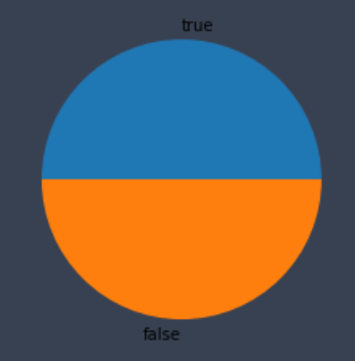
Fig 1.0 Pie Chart of Lie Label in Dataset
Fig 1.0 shows the distribution of the “lie” label for the data. As seen in the chart, the data is perfectly split between truth and lie at 50% per class. As such, the label is perfectly balanced and will not require additional consideration in the model, at least in terms of correcting misbalance.

Fig 1.1 Pie Chart of Sentiment Label in Dataset
Fig 1.1 shows the distribution of the “Sentiment” label for the text data. As can be observed in the chart, the class labels are once again perfectly split between positive and negative at 50% per class, once again, suggesting that handling class imbalance will not be an issue with this label.
To begin the comparison both models were trained using 10-fold cross validation. We wanted to know how the model performed during this stage in terms of the model’s accuracy with its predictions. The goal here is to determine what performance difference if any exist between the classification process for sentiment prediction and lie prediction using the text data.

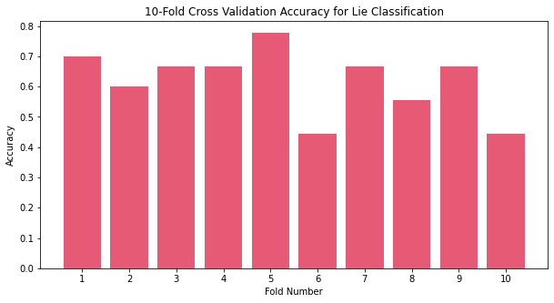
Fig 1.2 Per Fold Accuracy for Lie Classification using Multinomial Naïve Bayes
Figure 1.2 shows the per fold accuracy for lie classification using the multinomial naïve bayes model. The graph shows a fairly large range for accuracy for the model, with lows at or below 50% accuracy and highs close to 80% accuracy. The average for the lie classification was 61.89%, which is slightly better than random guessing at 50% when presented with a binary option. It should be noted that defaults for the model were used, and further hyper-parameter tuning was not performed as the goal here is to obtain a baseline performance between the two labels.

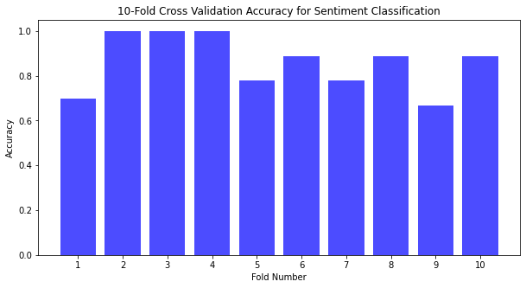
Fig 1.3 Per Fold Accuracy for Sentiment Classification using Multinomial Naïve Bayes
Fig 1.3 shows the per fold accuracy for sentiment classification using the multinomial naïve bayes model. Here we can observe a similar variation between the low and high values for the label classification task, however the accuracy values are much higher. The high values for this method are close to 100% accuracy and the low values are ~70% accuracy. This, as a result, yields a much higher average accuracy value at 85.89% accuracy, much higher than when compared with the lie classification model. This indicates that overall, at least, without further tuning, that the multinomial naïve bayes model is much more well suited to sentiment prediction than it to lie prediction when tested against the same text data. It should be noted that the data set used here was small, as even the sparse matrix that resulted from the total wordset only had dimensions of (92,1272). While this is not a tiny dataset by traditional standards, in terms of text data and the dictionaries that can result from the vectorization process, this is small. All of this is to say that when the same method is applied to a much larger dataset the outcome may vary, and with substantial training data lie prediction may improve. However, this it of itself brings up a distinction between the ease with which each task could be completed. If sentiment prediction is the goal, a relatively small training set used with the proper methods (cross validation for instance) can yield impressive results. On the other hand, with the same training set and methods, lie detection performance is fairly poor. This suggests that if lie detection was the end goal for the project, then a substantially larger dataset would have to be used for training. This further suggests that any development around a lie prediction platform would incur a much higher operational cost when compared to sentiment detection due to increase in needed data and the increase in compute power/time to process the data/model.

Top 20 Indicative Words for Lie Classification:
['food' 'restaurant' 'best' 'great' 'service' 'went' 'minutes' 'place'
'like' 'experience' 'ordered' 'plate' 'definitely' 'want' 'good' 'cold'
'dishes' 'menu' 'friends' 'pizza']
Fig 1.4 Top 20 Indicative Word List for Lie Classification Method
In figure 1.4 a list of the top 20 most indicative words for lie classification can be observed. And, as may be noticeable, many of the words make little sense when trying to think about how language is used when lying. Examples like “pizza”, “best”, “food”, “friends” are rather humorous when considering the context of the list, but not as informative as one might initially hope.

Top 20 Indicative Words for Sentiment Classification
['restaurant' 'food' 'place' 'went' 'minutes' 'ordered' 'terrible' 'salad'
'dishes' 'bad' 'just' 'order' 'good' 'pizza' 'came' 'wait' 'waiter'
'come' 'service' 'like']
Fig 1.5 Top 20 Indicative Word List for Sentiment Classification Method
In figure 1.5 a list of the top 20 most indicative words for sentiment classification can be observed. Here we can see many of the same words as shown in the lie classification method, such as “restaurant”, “food”, “good”, and “like”. This reinforces the prior belief that the model did not pick up on words that were truly significant in being able to predict lie labels, however, using many of the same words the model was able to perform fairly well in sentiment prediction. It should be noted here that the word list were generated using log probabilities. This method was chosen as Multinomial Naïve Bayes, compared to other methods of Naïve Bayes, utilizes frequency counts in determining the importance of a word. As such, since the frequency counts are what are being weighted for importance, we can use log probabilities of each of the frequencies to determine a relative score. This score is then used to determine the 20 most “weighted” words in the text data.

Now we compare the difference in base performance between the multinomial naïve bayes model and the Bernoulli model. As with the previous models, separate models will be made for each label, “lie” and “sentiment”. And as with the previous models, 10-Fold Cross Validation will once again be utilized to handle the training steps and data split for the Bernoulli model.
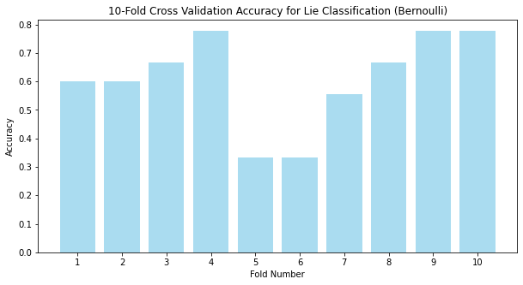
Fig 1.6 Barplot of Per Fold Accuracy Bernoulli Method Lie Classification
In Figure 1.6 the per fold accuracy for the Bernoulli method used in the lie classification problem can be observed. Here the mean accuracy is 60.89%, which is a 1% decrease in performance for lie classification when compared the multinomial naïve bayes base model. The plot also exhibits similar behavior to that seen in the previous model applied to the same problem, where the highest values are ~80% accuracy and the lowest values are well below 50%. Overall, not a very significant performance gain or loss when switching to this model for this particular task.

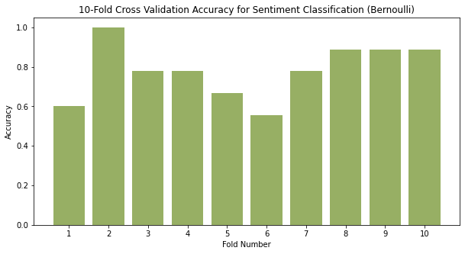
Fig 1.7 Barplot of Per Fold Accuracy Bernoulli Method Sentiment Classification
In figure 1.7 the per fold accuracy for the Bernoulli Method used in the sentiment classification task can be observed. Here the mean accuracy is 78.22%, a much more meaningful ~7% loss in performance when compared to the naïve bayes method. From the barplot, the lowest values in the plot are lower than the lowest values in the naïve bayes plot for sentiment classification. This suggest, at least on an initial run, that for sentiment classification, when comparing base model performance, multinomial naïve bayes may be the more performant model.
Next, we take a look at varying the Alpha values within the Benroulli model itself to see if the model could perform better with hyper parameter tuning. We selected the values 0.01, 0.5, 1.0 (default value run previously), and 5.0. This is not meant to be an exhaustive comparison of selection, but rather a visualization on how tuning these parameters can affect the model performance.
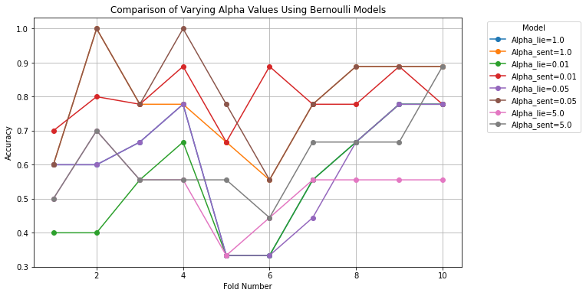
Fig 1.8 Line Graph of Bernoulli Models with Varying Alpha Values
The resulting accuracies per fold using the Bernoulli model while varying the Alpha value can be seen in Figure 1.8. Here, there was performance lift with a couple of the models. Notably, the sentiment classification accuracy score rose for both alpha values 0.01 and 0.5, at 79.44% and 81.56% respectively. When compared to the base models value of 78.22% this is not a major uplift in performance, however, it does suggest that there may exist a value x, where 0.01<x<1 will lead to a model as performant if not more so than the base multinomial naïve bayes model. For lie label classification, varying the alpha did not produce the same desirable uplift in performance as with sentiment classification. For all values of alpha, the lie classification mean accuracy dropped anywhere from 0.5%-7.0% when compared to the base model, suggesting that the alpha value has little to do with the difference in performance between labels. It should be noted that the alpha hyper parameter was chosen as the parameter to tune for several reasons. The Prior Probability of the classes did not need to be tuned as the classes are perfectly balanced with the same number of observations in both class for each label. Additionally, do not need to perform binarization as the vectorizer handles this and the data is already in binary vectors as a result of the vectorization process.
Next we take a look at how varying the ngram parameter in the pre processing stage can affect the model performance, and, if as a result, it will help increase the model performance. We try a couple of different setups with the ngram setting, using Unigrams and Bigrams, using Bigrams only, and using Unigrams, Bigrams, and Trigrams for the ngram setting. First we take a look at using both Unigrams and Bigrams in the Bernoulli model.

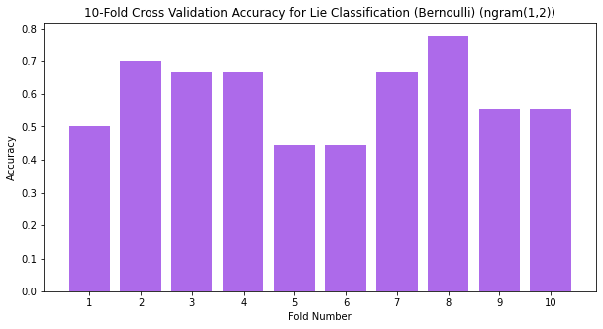
Fig 1.9 Barplot of Per Fold Accuracy for Bernoulli Lie Classification using ngram(1,2)
In figure 1.9 the per fold accuracy can be seen for the Bernoulli model when using both unigrams and bigrams in the pre processing steps, in lie classification. Here the mean accuracy did not change significantly, dropping less than 0.5% to 59.78%. While using the ngram(1,2) selection did not help improve the models performance, it did not degrade the model performance either.
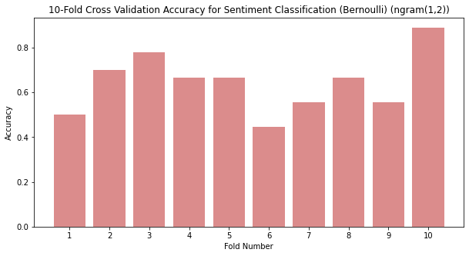
Fig 2.0 Barplot of Per Fold Accuracy for Bernoulli Sentiment Classification using ngram(1,2)
In figure 2.0 the per fold accuracy for sentiment classification using the Bernoulli model with ngram(1,2) can be seen. Here the performance was degraded sharply, dropping from 78.22% mean accuracy down to 64.22% suggesting that for sentiment classification the model does not benefit nor require ngrams to be declared in order to make meaningful assertions about the text data. To show how ngrams can be used to seriously degrade a models performance, we next use the Bernoulli model again, however this time with ngram(2,2), retaining only bigrams from the data.
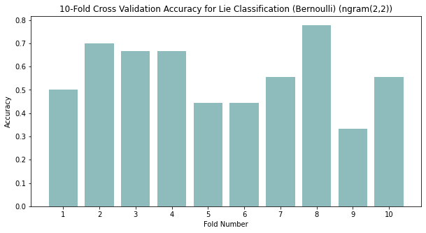
Fig 2.1 Barplot of Per Fold Accuracy for Bernoulli Lie Classification using ngram(2,2)
Figure 2.1 shows the per fold accuracy for lie classification using the Bernoulli model but this time using only bigrams as specified by ngram(2,2). For lie classification, making this change had a small effect dropping the accuracy ~3% to 56.44% for mean accuracy across all 10 folds. While this is certainly worse, it is not a very drastic reduction in the overall accuracy.
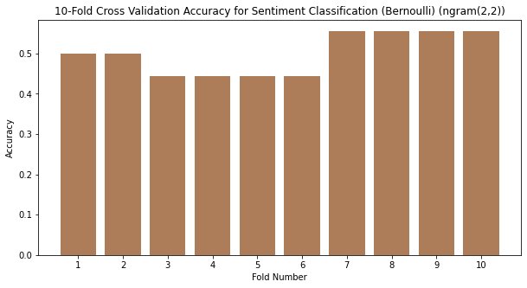
Fig 2.1 Barplot of Per Fold Accuracy for Bernoulli Sentiment Classification using ngram(2,2)
The same cannot be said for the mean accuracy for the sentiment classification. As can be seen in figure 2.1, the per fold accuracy is sharply reduced when compared to the ngram(1,2) model or the base model. With a mean accuracy of 50%, this model is as accurate as random guessing between the two label classes. This shows that while ngram certainly is a parameter that can be tuned in the pre processing stage, care should be exercised in order to prevent model degradation.
Next, we apply the same ngram settings to the multinomial naïve bayes to compare the performance of this model versus the Bernoulli method and the ngram usage versus the base models.
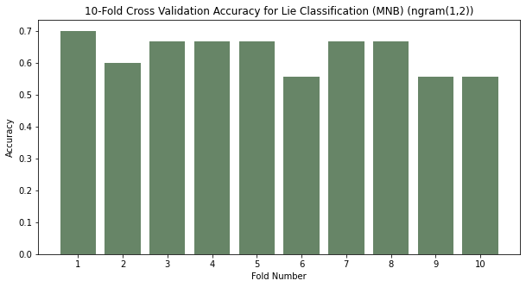
Fig 2.2 Barplot of Per Fold Accuracy for Multinomial Naïve Bayes Lie Classification w/ngram(1,2)
Figure 2.2 shows the per fold accuracy for lie classification using the multinomial naïve bayes method in combination with the ngram restriction of using both unigrams and bigrams. The mean accuracy for this model is 63%, a slight increase of ~1.1% over the base model. This is in line with the ngram(1,2) restriction placed on the Bernoulli model. What this suggest, is that the vectorization process does not help the model make better “sense” of the lie classification tasks. As such, whether considered as unigrams or as bigrams the text data has little context for the model to extract in relation to this classification problem. Further, this suggest that if lie detection is the end goal of a classification model, then other avenues to increase accuracy will be required, such as finding a way to make the words more meaningful in relation to the problem such as via weighting. How to best accomplish this is beyond the scope of this paper.

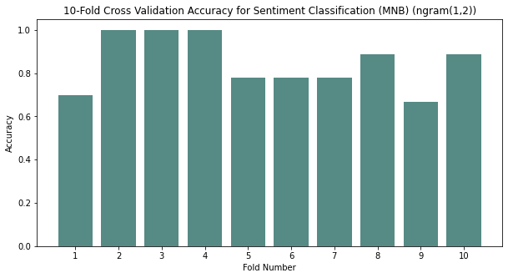
Fig 2.3 Barplot of per Fold Accuracy for Multinomial Naïve Bayes Sentiment Classification w/ngram(1,2)
Figure 2.3 shows the per fold accuracy for sentiment classification using the multinomial naïve bayes model in combination with the ngram restriction of using both unigrams and bigrams. Here the mean accuracy drops slightly to 84.78%, an overall decrease of ~1%. Here we can see that the multinomial naïve bayes model was able to handle the addition of the bigrams much better than the Bernoulli model as the performance was hardly affected here, where as in the Bernoulli model the performance was dropped almost 10%. This additionally suggest that, at least based off of this information, that in situations where bigrams are a known entity in the data and they are desirable then multinomial naïve bayes may be the model of choice. When testing for the accuracy of multinomial naïve bayes models when using only bigrams, similar results were obtained as when using the Bernoulli model. That is, lie classification was hardly affected dropping ~2% to 61.11% mean accuracy, while sentiment classification saw a large hit to its accuracy reduction with a mean accuracy of 58.67%. This reinforces the point above about parameter tuning for lie classification and model performance.
Next comparison between the previous base models will be made with models utilizing the built in dictionaries included with each vectorizer. For all previous models, the NLTK English stop words dictionary was used, as is, and unmodified. However, now we will compare both the Bernoulli model and the Multinomial Naïve Bayes models using the stop word dictionaries included in the vectorizers themselves. For the Multinomial Naïve Bayes model, the mean accuracy for lie classification was 53.22%, a sharp reduction in the accuracy. This is interesting as the only difference here is the change in dictionaries when compare to the base model. However, even more interesting, is the fact that the sentiment classification using the multinomial naïve base resulted in an average accuracy of 85.89%, a value identical to the original testing. For the Bernoulli model using the included dictionary, the lie classification yielded an average accuracy of 58.78%, a slight drop when compared to the 60.89% yielded by the base model we are comparing to. Once again, the sentiment classification using the Bernoulli model mimics the original score yielding a 78.22% average accuracy. At this point the results for both models using the built in dictionaries should be disregarded until verification testing can be performed, as this may be more than mere coincidence.
And finally, a brief comparison was made between the models to test how sensitive the models are to the word list they used to make their conclusions. In this case, we took 5 words in total out of the top 20 word list generated for both positive and negative sentiment. Those words were "went", "want", "friends", "just", "came", and "come". These words were manually selected as they were believed to carry the least amount of importance for the model. The NLTK stop word list was once again used, only this time with the 5 additional words added to the list. For the Bernoulli method the results were the same as with the base model, with a lie classification mean accuracy of 60.89% and a sentiment classification mean accuracy of 78.22%. The Multinomial Naïve Bayes model provided slightly more interesting results, with a mean accuracy of 60.89% for the lie classification, and 84.78% for the sentiment classification. This is interesting both because the lie classification in this case is the same value as for the Bernoulli model, and because the sentiment classification does display a difference albeit a very small one from the base model at 1%.

Conclusion
Text data can generate a wealth of knowledge regarding customer opinions and feelings towards business and enterprise operations. Sentiment analysis allows us to gain this insight, but what about other text classification problems? In an attempt to answer this, we measured the performance of multinomial naïve bayes and Bernoulli models against a collection of text in the form of restaurant reviews across two labels, sentiment and lies. The sentiment analysis performed well with the naïve bayes model out of the box returning an average accuracy of 85.89% in 10-Fold Cross Validation. The Bernoulli model performed slightly worse with a 78.22% accuracy. The lie analysis performed markedly worse at 61.89% accuracy in 10-Fold Cross Validation using multinomial naïve bayes, and 58.78% using Bernoulli. Hyper parameter tuning was performed on the Bernoulli model in the form of alpha modification and it was found that some values yielded increased performance for the sentiment classification task. Ngram tuning was tested next, with ngram(1,2) and ngram(2,2) being compared in both models. It was found that tuning ngrams in this instance yielded minimal to no performance benefit in the best case and serious model degradation in the worst case. A comparison between included and imported dictionaries was made, it was found that the model performance either declined minimally or remained exactly the same, though these results require further verification. Lastly, a comparison between the base stop words list included with NLTK and a modified stop words list would affect the performance of the model. It was found that this difference is either negligible or negative depending on the model and label. Overall, this suggests that with a minimal dataset sentiment prediction is possible if a high degree of accuracy is not required. However, attempting to perform lie detection with same minimal dataset is not nearly as effective, and suggests that a heavy amount of work would be required to obtain a similar accuracy. Further, this shows that with the proper pre processing steps and parameter tuning meaningful performance uplifts are possible.

*NOTE: Some of this content may look familiar, the assignment from HW4 was taken and used as a base for this assignment. Portions of the document are the same such as the first model analysis and parts of the intro and conclusion, however the rest has been modified in order to accommodate this assignment. The same with the code, the original code from HW4 was taken and used as a base for this assignment. Stated for transparency.

